41.27: a) Nitrogen is the seventh element (Z = 7). 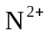 has two electrons removed, so there are 5 remaining electrons  electron configuration is 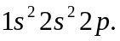
b) 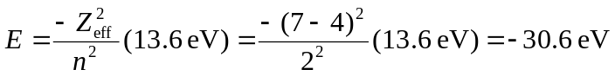
c) Phosphorous is the fifteenth element (Z = 15). 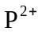 has 13 electrons, so the electron configuration is 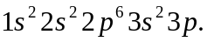
d) The least tightly held electron: 